# Product Requirement Document

## Accountancy Externalisation – Republic of Ireland.

### Background

The current accounting module in the Merlin system does not support the two-thirds VAT rule in Ireland. This limitation can lead to inconsistencies that prevent customers from receiving accurate sales values, disrupt daily operations, and result in non-compliance with regulatory and financial standards.

### Governance ( )

* Product – Micheal Aderinto
* Business Analysis – Heather Gower
* Engineering – Eduardo Soroa Pina
* Quality Assurance – Luca Santarelli

### Objectives & Scope

|  |  |
| --- | --- |
| **What is the problem we’re trying to answer?** | ***Problem Statement:***  As Merlin PMS prepares to expand into the Irish market, the current financial core of the system presents significant challenges. The existing pricing and tax calculation frameworks are not equipped to handle the EU two-thirds VAT rule, which is critical for compliance in this market. This limitation threatens operational efficiency and poses risks in regulatory adherence, potentially alienating new users in Ireland.  ***Impact of the Problem:***  Scalability and Global Expansion: Limitations in tax calculations to the UK and ROI hinder the scalability of the system and its ability to cater to a global customer base, particularly in Ireland.  Financial Accuracy and Compliance: Inaccurate price calculations and tax handling can lead to financial discrepancies, non-compliance with Irish/EU tax regulations, and potential financial penalties or audits.  Customer Satisfaction: Price inconsistencies impacting customer trust in Merlin.  Competitive Disadvantage: Inconsistencies in pricing and tax calculations may put the business at a competitive disadvantage compared to our competitors.  **Goals and Objectives:**  **Goal:** Enhance the financial core of Merlin PMS to ensure accurate and consistent pricing and tax calculations, including the management of two-thirds VAT. This upgrade will also simplify account management and financial reporting. The goal of this enhancement is to improve system scalability, operational efficiency, regulatory compliance, and user-friendly accessibility within the Merlin PMS.  **Objectives:**   1. Expand Tax Handling:    1. Objective: Extend tax calculation support beyond the UK and ROI, to the Republic of Ireland.    2. Key Results: Implement tax calculation capabilities for Ireland, including compliance with the two-thirds VAT rule. 2. Optimize Price Calculations:    1. Objective: Standardize price calculations across different code locations to eliminate deviations and rounding discrepancies.    2. Key Results: Reduce price inconsistencies and improve accuracy, ensuring that customers receive specific sell values without deviations. 3. Ensure Regulatory Compliance:    1. Objective: Ensure compliance with tax regulations in the Republic of Ireland, specifically addressing the two-thirds VAT requirement.    2. Key Results: Implement tax calculation rules that align with Irish / EU laws, ensuring accurate tax calculations and adherence to regulatory requirements. 4. Enhance Customer Satisfaction:    1. Objective: Improve customer satisfaction by providing accurate price calculations and tax handling.    2. Key Results: Deliver a reliable accounting system that meets customer expectations, reduces pricing discrepancies, and ensures seamless tax calculations. |
| **Who is having the problem?** | * Tax calculations limited to the UK & ROI affect all potential customers in Ireland. |
| **How do we know it’s a problem?** | * Requirements for entry into the Republic of Ireland. |
| **Where does the problem exist?** | Problem exists in the current implementation of Merlin and associated integrations. |
| **Why are we trying to fix the problem?** | For market penetration into the Republic of Ireland. To fix pricing calculation discrepancies within Merlin |

### Hypothesis

We believe that if we enhance the tax calculation capabilities to support the two-thirds VAT rule for Ireland, standardize price calculations to eliminate inconsistencies, we will be able to expand to Ireland, observe improved accuracy in price calculations, increased system efficiency, enhanced user experience, regulatory compliance, and ultimately, higher customer satisfaction.

### Market Size

Industry revenue has grown at a CAGR of 11.4 % over the past five years, to reach an estimated €639.1m in 2024.

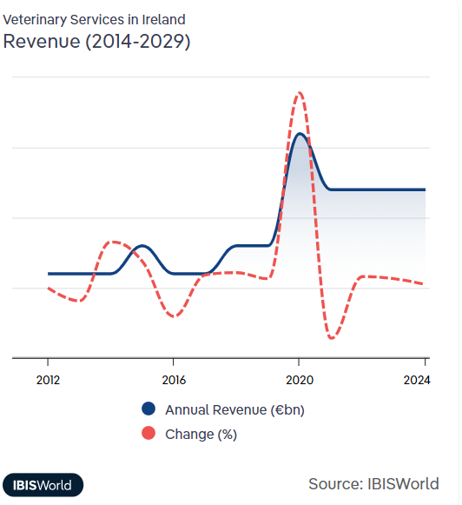

### Business Requirements

### High-Level Product/Service/Feature

|  |  |
| --- | --- |
| **Name** | Tax Management |
| **Description** | Deals with all tax-related functionality, including setting tax statuses and displaying tax information, specifically regarding the two-thirds VAT rule for Ireland. This ensures compliance with tax regulations and accurate tax reporting.  Overview of the Two-Thirds VAT Rule  The two-thirds VAT rule is relevant when dealing with the supply of services in the European Union, including the Republic of Ireland. This rule applies to mixed supplies involving both goods and services. Here's how it works:   * Threshold Determination: If the value of the goods in a mixed supply constitutes more than two-thirds of the total value of the supply, the entire transaction is treated as a supply of goods for VAT purposes. * Application: This means that the VAT rate applicable to goods will be applied to the entire transaction, rather than the VAT rate for services. |
| **Purpose** | Simplify tax compliance. Reduce risk of tax-related errors. Save time on tax calculations. Easily generate tax reports |
| **Priority** | Must Have |

### UX Plan

|  |  |
| --- | --- |
| **Design Brief** | Link to document |
| **High Level Requirements** | Link to HL requirements |
| **Workshop Outputs** | N/A |
| **Low-Fi Wires** | N/A |
| **Prototype** | N/A |
| **Final Designs** | N/A |
| **Confluence Page** | [Link to Confluence Page](https://mwiah.atlassian.net/wiki/spaces/MDB/pages/1441923085/Accounting+Externalisation+Product+Page+-+Republic+of+Ireland) |
| **Jira Board** | Link to board |

### Technical Specifications

|  |  |
| --- | --- |
| **Architecture** | Solution Design |
| **API Specification** | TBA |
| **Transaction** | N/A |
| **Infrastructure** |  |

### Reporting / Tracking

|  |  |  |  |
| --- | --- | --- | --- |
| **Key performance indicator** | **Baseline** | **Target** | **Timeframe** |
|  |  |  |  |
|  |  |  |  |

Approvals & Sign-Off

|  |  |  |
| --- | --- | --- |
| **Responsibility** | **Name** | **Sign off** |
| Group Product Manager | Ryan Norton |  |
| Engineering Manager | Arthi Shridharan |  |